dhamodaran G - Performance Report

This report provides detailed insights into student's performance by topic, subtopic, and learning fundamentals.

# Learning Fundamentals

Listening: 97.98%

Grasping: 10.00%

Retention: 10.00%

Application: nan%

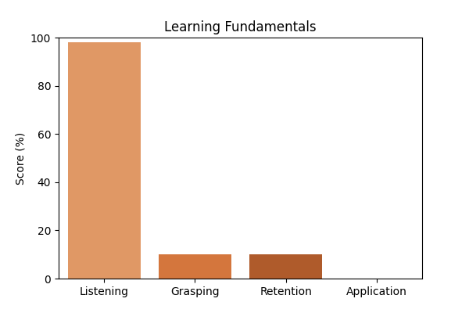

# Topic Accuracy

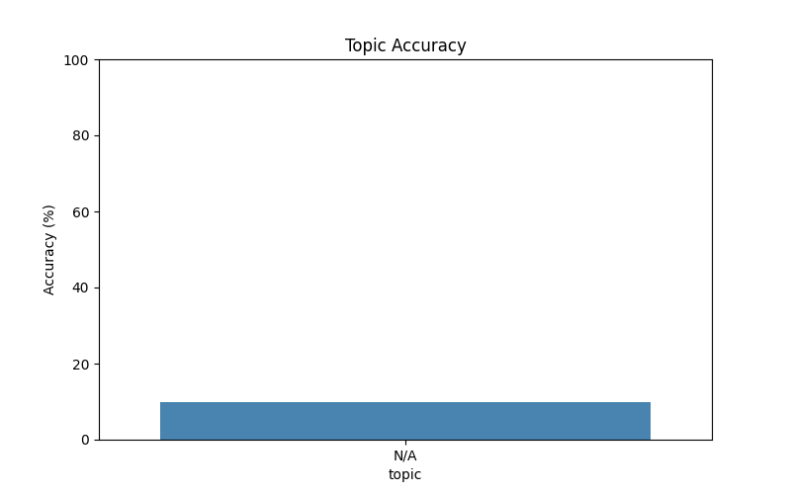

# Subtopic Accuracy

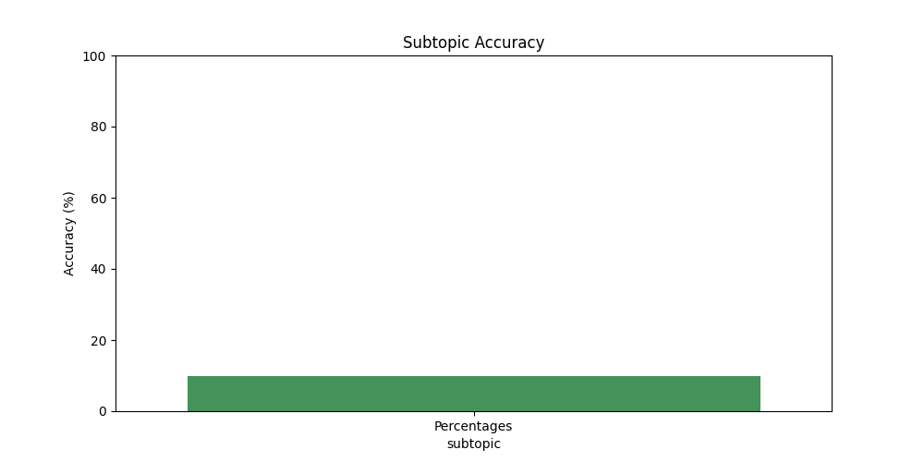

# Question-wise Performance

Q: 3.5 can be expressed in terms of percentage as:  
Topic/Subtopic: N/A / Percentages  
Your Answer: b | Correct Answer: d | ❌ Incorrect | Time Taken: 2.07s

Q: What is 15 percent of Rs. 34?  
Topic/Subtopic: N/A / Percentages  
Your Answer: a | Correct Answer: d | ❌ Incorrect | Time Taken: 2.59s

Q: 63% of 3 4/7 is:  
Topic/Subtopic: N/A / Percentages  
Your Answer: a | Correct Answer: a | ✅ Correct | Time Taken: 1.98s

Q: 860% of 50 + 50% of 860 =?  
Topic/Subtopic: N/A / Percentages  
Your Answer: b | Correct Answer: c | ❌ Incorrect | Time Taken: 3.08s

Q: 45% of 750 - 25% of 480 =?  
Topic/Subtopic: N/A / Percentages  
Your Answer: c | Correct Answer: b | ❌ Incorrect | Time Taken: 1.58s

Q: 218% of 1674 = ? × 1800  
Topic/Subtopic: N/A / Percentages  
Your Answer: c | Correct Answer: d | ❌ Incorrect | Time Taken: 2.35s

Q: 5 out of 2250 parts of earth is sulphur. What is the percentage of sulphur in earth:  
Topic/Subtopic: N/A / Percentages  
Your Answer: c | Correct Answer: b | ❌ Incorrect | Time Taken: 0.0s

Q: What percent of 7.2 kg is 18 gms?  
Topic/Subtopic: N/A / Percentages  
Your Answer: a | Correct Answer: b | ❌ Incorrect | Time Taken: 2.61s

Q: 0.01 is what percent of 0.1?  
Topic/Subtopic: N/A / Percentages  
Your Answer: d | Correct Answer: b | ❌ Incorrect | Time Taken: 1.87s

Q: Which one of the following shows the best percentage?  
Topic/Subtopic: N/A / Percentages  
Your Answer: a | Correct Answer: b | ❌ Incorrect | Time Taken: 2.05s

# AI Analysis & Motivation

dhamodaran G effectively applied concepts correctly. dhamodaran G has shown consistent effort and progress. Overall accuracy: 10.00%, Average time per question: 2.02s. Areas to improve: N/A. With continued practice, dhamodaran G can achieve even higher accuracy.